## 1、确保生产了逆向代码

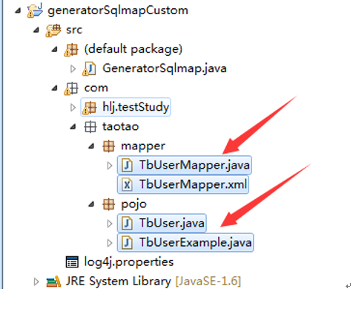

## 2、配置spring数据源

### 1、引入实体类和Examply

|  |
| --- |
| <bean id=*"sqlSessionFactory"* class=*"org.mybatis.spring.SqlSessionFactoryBean"*>  <property name=*"dataSource"* ref=*"dataSource"* />  <property name=*"typeAliasesPackage"*>  <value>  org.dsp.core.model.entity  org.dsp.ea.pay.model.entity  org.dsp.ea.pout.model.entity  org.dsp.ea.accestablish.model.entity  org.dsp.ea.contribution.model.entity  org.dsp.ea.modifyInfo.model.entity  org.dsp.oa.model.entity  </value>  </property>  </bean> |

#### 1、以org.dsp.oa.model.entity为例查看图片

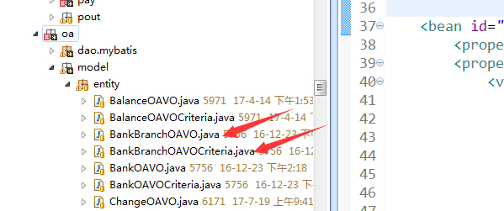

### 2、引入mapper.java 和mapper.xml

|  |
| --- |
| <bean class=*"org.mybatis.spring.mapper.MapperScannerConfigurer"*>  <property name=*"sqlSessionFactory"* ref=*"sqlSessionFactory"* />  <property name=*"basePackage"*>  <value>  org.dsp.core.dao.mybatis  org.dsp.ea.pay.dao.mybatis  org.dsp.ea.pout.dao.mybatis  org.dsp.ea.accestablish.dao.mybatis  org.dsp.ea.contribution.dao.mybatis  org.dsp.ea.modifyInfo.dao.mybatis  org.dsp.oa.dao.mybatis  </value>  </property>  </bean> |

#### 1、以org.dsp.oa.dao.mybatis为例查看图片，里面具有mapper.java和mappe.xml

